TYPES OF VECTORDATABASES
https://chatgpt.com/g/g-p-69de9136f97c8191bcb65659d7bc7960-vectordatabases/project

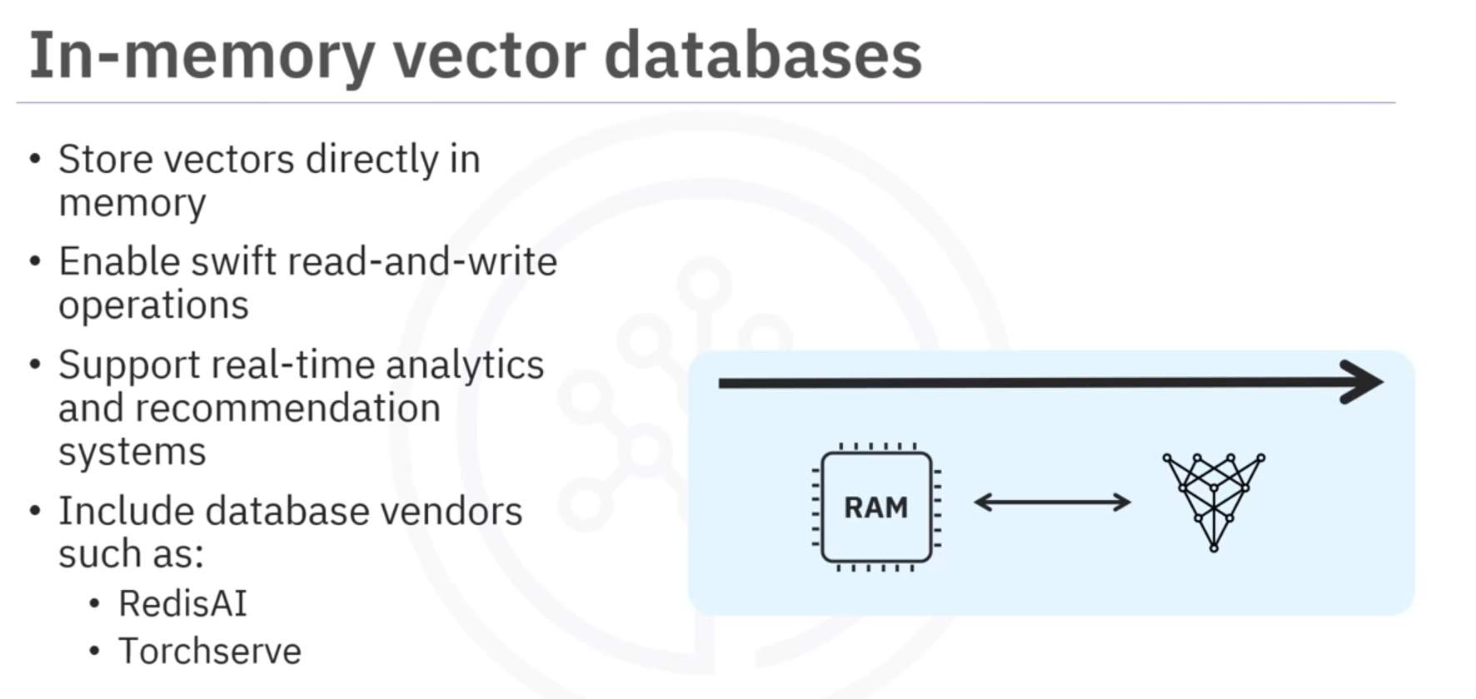

Userful for tasks like similarity search, classification, and clustering.
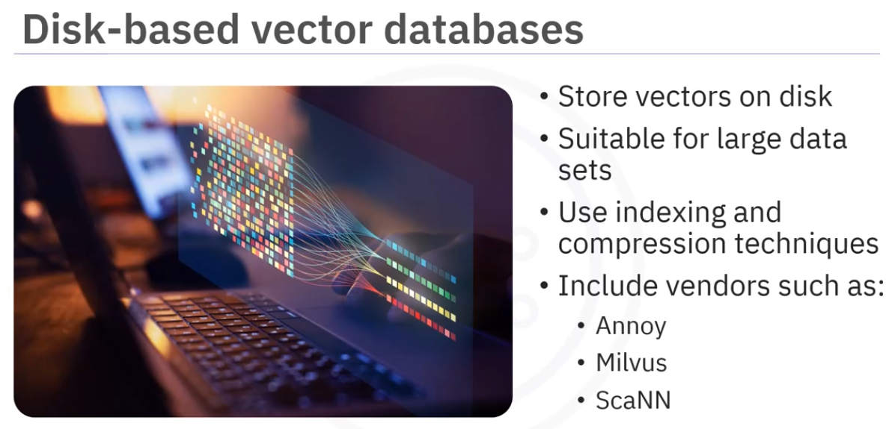
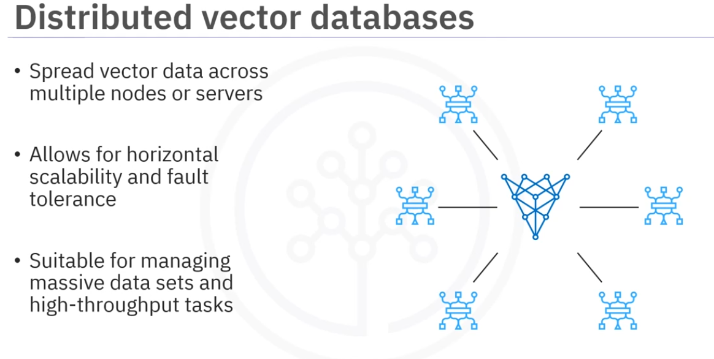

Eg. FAISS (Facebook AI Similarity Search)
, Elasticsearch with Vector Plugin, and Dask-ML
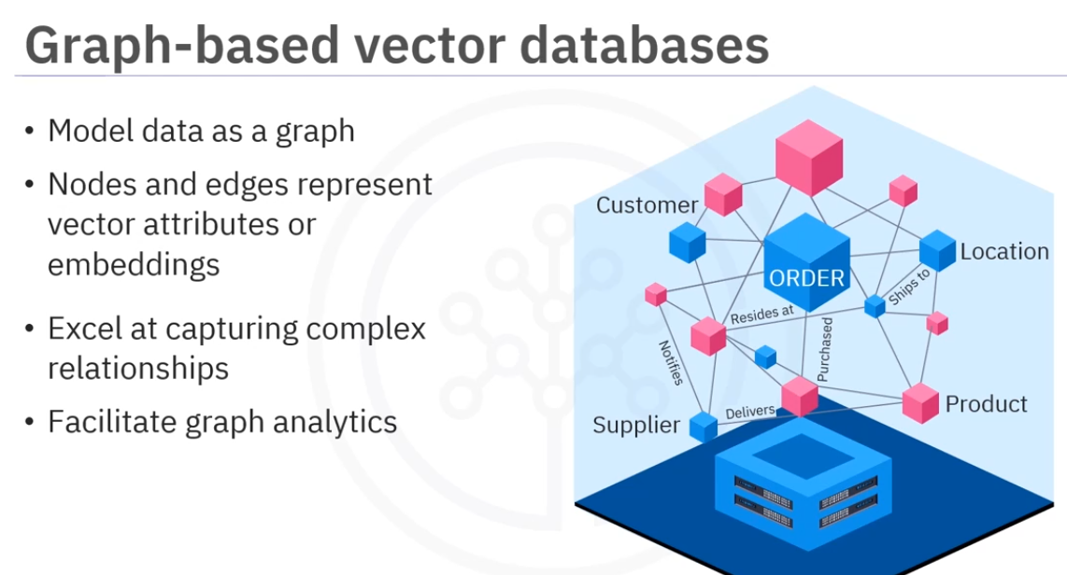 eg. Neo4j, Amazon Neptune and TierGraph. Neo4j capabilities support social network analysis, ​recommendation systems, and knowledge graphs. ​

